Create Virtual Machine - Azure Portal Lab

In this lab, you will learn how to create virtual machines using Azure Portal.

Creating a Virtual Machine using Azure Portal

In this task you will create a Virtual Machine in Azure Portal.

1. Sign in to the [Azure Portal](https://portal.azure.com/).
2. On the Left Side bar, click **+ NEW** and then click on **See all**.

[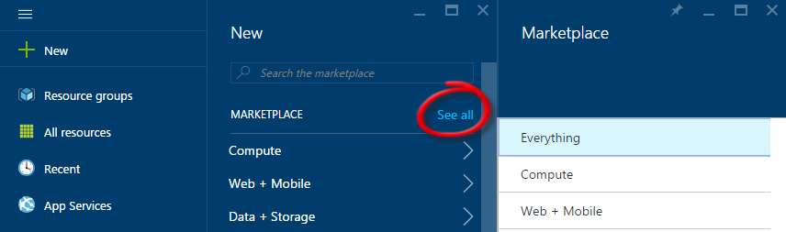](https://github.com/opsgility/DevCamp/blob/master/HOL/create-virtual-machine/images/click-new-and-everything.png?raw=true)

*Creating a VM*

1. Click **Compute** and then click the **Windows Server** tile.

[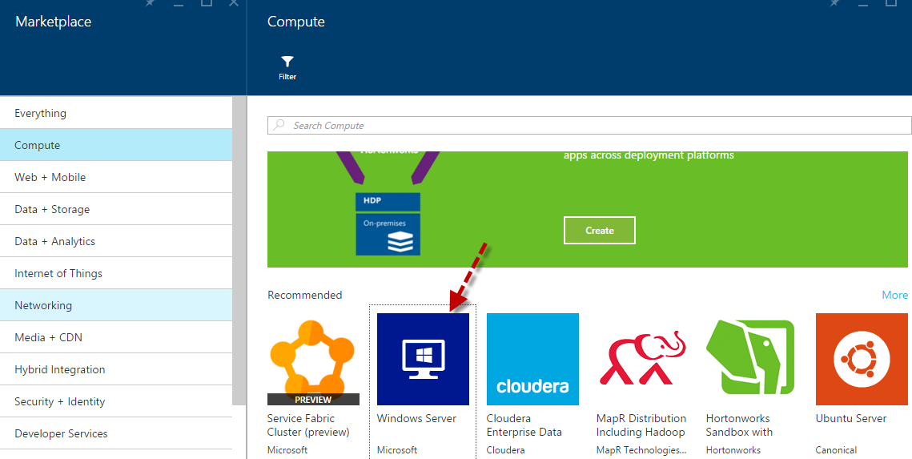](https://github.com/opsgility/DevCamp/blob/master/HOL/create-virtual-machine/images/creating-compute-vm-winserver.png?raw=true)

*Creating a VM - Click Virtual Machines then the Windows Server tile*

1. A new blade opens with the different images available for **Windows Server**. Find and click **Windows Server 2012 R2 Datacenter**.

[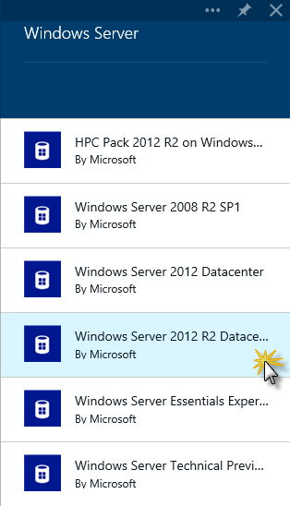](https://github.com/opsgility/DevCamp/blob/master/HOL/create-virtual-machine/images/creating-vm-select-image.png?raw=true)

*Creating a VM - Select the image to use*

1. In the **Windows Server 2012 R2 Datacenter** blade, Select **'Resource Manager'** from dropdown **select a deployment model**, and then click **Create**.

[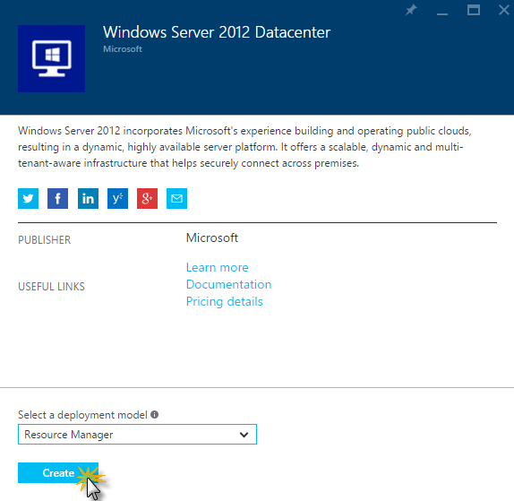](https://github.com/opsgility/DevCamp/blob/master/HOL/create-virtual-machine/images/creating-vm-confirm-image.png?raw=true)

*Creating a VM - Click Create to confirm the use of this image*

1. On the **Create Virtual Machine** blade that opens, enter:
   * **Name**: virtual machine name (e.g. testvm)
   * **User Name**: administrator user for the virtual machine (e.g. adminUser)
   * **Password**: unique password for the administrator account
   * **Subscription**: Select if you have multiple subscriptions
   * **Resource**: New or Existing (e.g. create-vm)
   * **Location**: select the location for the virtual machine. (e.g. West US)

[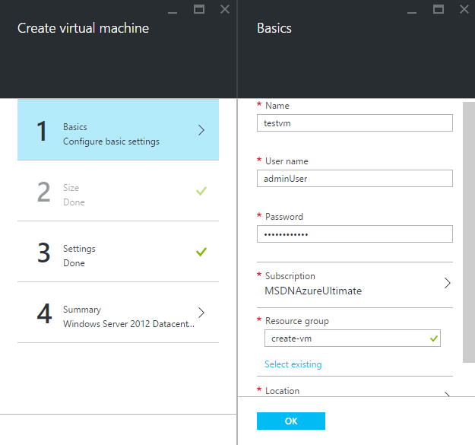](https://github.com/opsgility/DevCamp/blob/master/HOL/create-virtual-machine/images/create-vm-resource-basic-config.png?raw=true)

*Creating a VM - Basic Configuration*

* + **Size**: select the size of virtual machine needed. (Select **See All** for checking all sizes and details)

[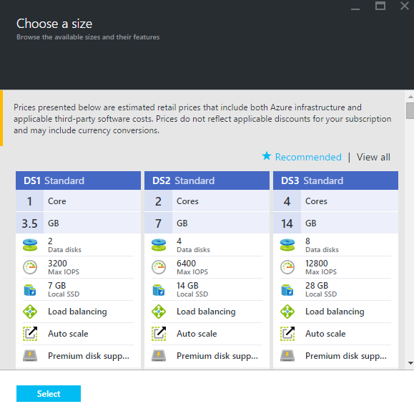](https://github.com/opsgility/DevCamp/blob/master/HOL/create-virtual-machine/images/create-vm-resource-choose-size.png?raw=true)

*Creating a VM - Types of Sizes*

* + **Disk Type**: select the disk size. (e.g. Standard/Premium(SSD))
  + **storage account**: storage account details(if existing select the storage account at specified location or create new)
  + **virtual network**: virtual network for the virtual machine to create
  + **Subnet**: subnets under one Virtual network
  + **Public IP address**: public IP address

[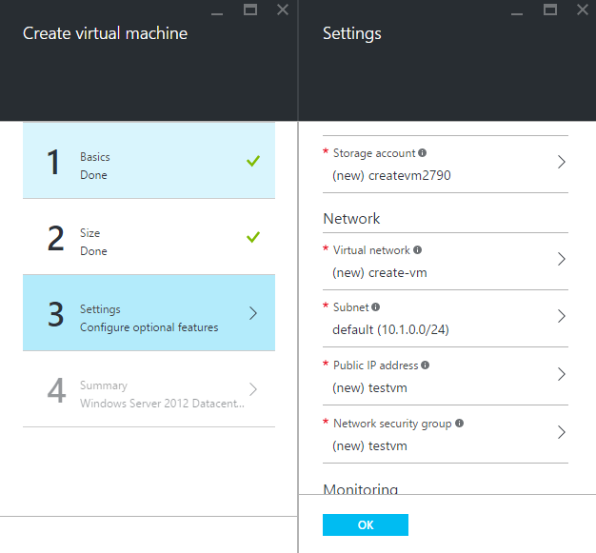](https://github.com/opsgility/DevCamp/blob/master/HOL/create-virtual-machine/images/create-vm-resource-settings-config.png?raw=true)

*Creating a VM - Settings*

* + **Summary**: virtual machine summary details before you click on create.

[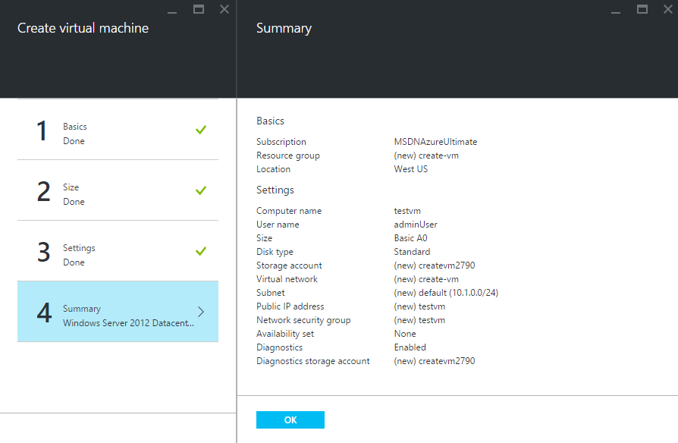](https://github.com/opsgility/DevCamp/blob/master/HOL/create-virtual-machine/images/create-vm-summary.png?raw=true)

*Creating a VM - Summary*

**Note:** Premium storage, available for DS-series virtual machines in certain regions. For details, see [Premium Storage: High-Performance Storage for Azure Virtual Machine Workloads](http://azure.microsoft.com/en-us/documentation/articles/storage-premium-storage-preview-portal/).

1. Click **OK**.
2. The VM will start being created. You can monitor the creation progress on the **Notifications**. As this can take a few minutes, this task ends here.

[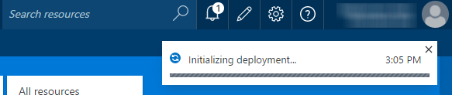](https://github.com/opsgility/DevCamp/blob/master/HOL/create-virtual-machine/images/creating-vm-monitor-progress-on-the-notifi.png?raw=true)

*Creating a VM - Monitor progress in the Notifications Hub*

**Note:** After the VM is created, the Virtual Machine blade will open. A pin for the VM (e.g. azureVM) is also added to the **Startboard**. You can use it to access the VM.

[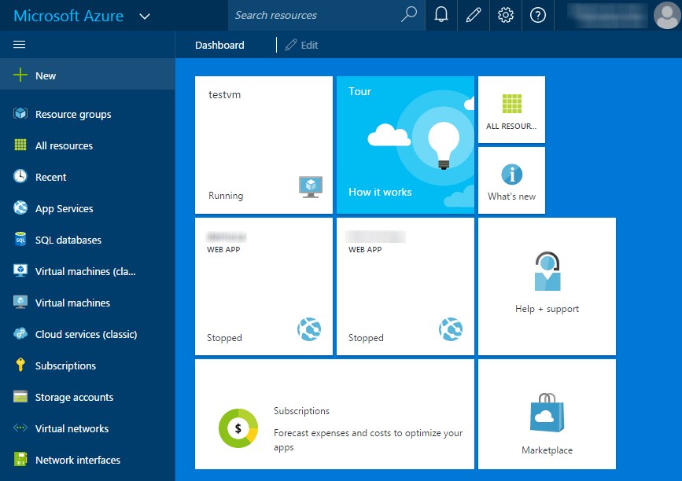](https://github.com/opsgility/DevCamp/blob/master/HOL/create-virtual-machine/images/creating-vm-pin-in-startboard-after-creation.png?raw=true)

*Creating a VM - A pin was created in the Startboard*

Once the virtual machine has been created you can attach new or existing data disks to the Virtual Machine. See [About Virtual Machine Disks in Azure](https://msdn.microsoft.com/library/azure/dn790303.aspx) for more information.

[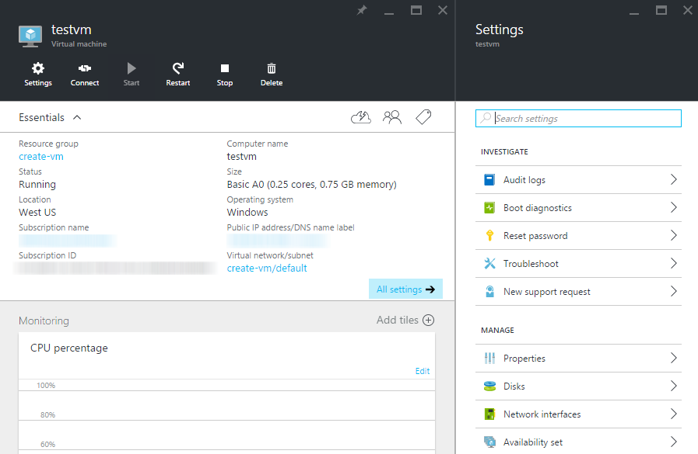](https://github.com/opsgility/DevCamp/blob/master/HOL/create-virtual-machine/images/create-vm-details-created.png?raw=true)

*Virtual Machine details after Creation*

*END OF DOCUMENT*